Agile(灵活的) processes put increased pressure on testers.

We need our software to be dependable,Testing is one way to assess dependability.

Software testing is a process, or a series of processes, designed to make sure computer code does what it was designed to do and, conversely, that it does not do anything unintended.

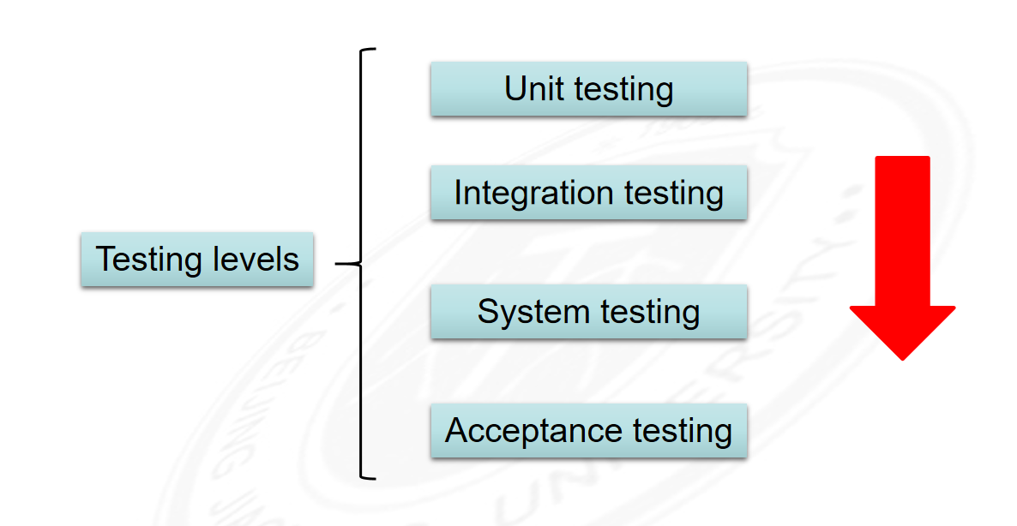

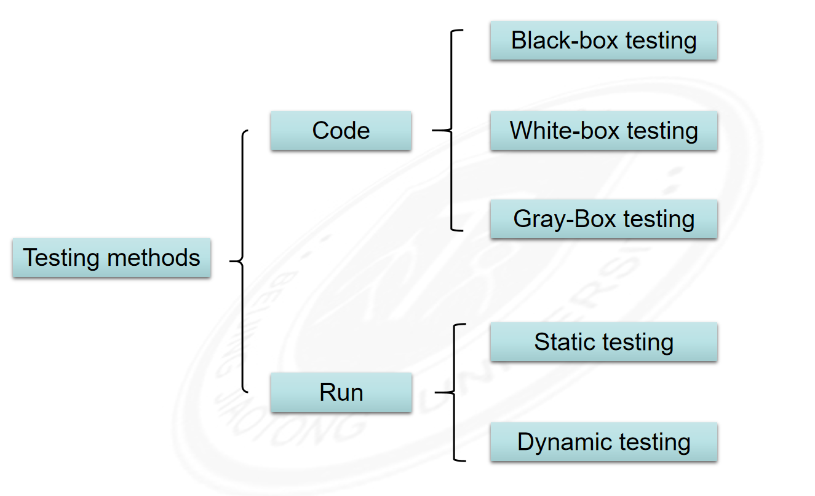

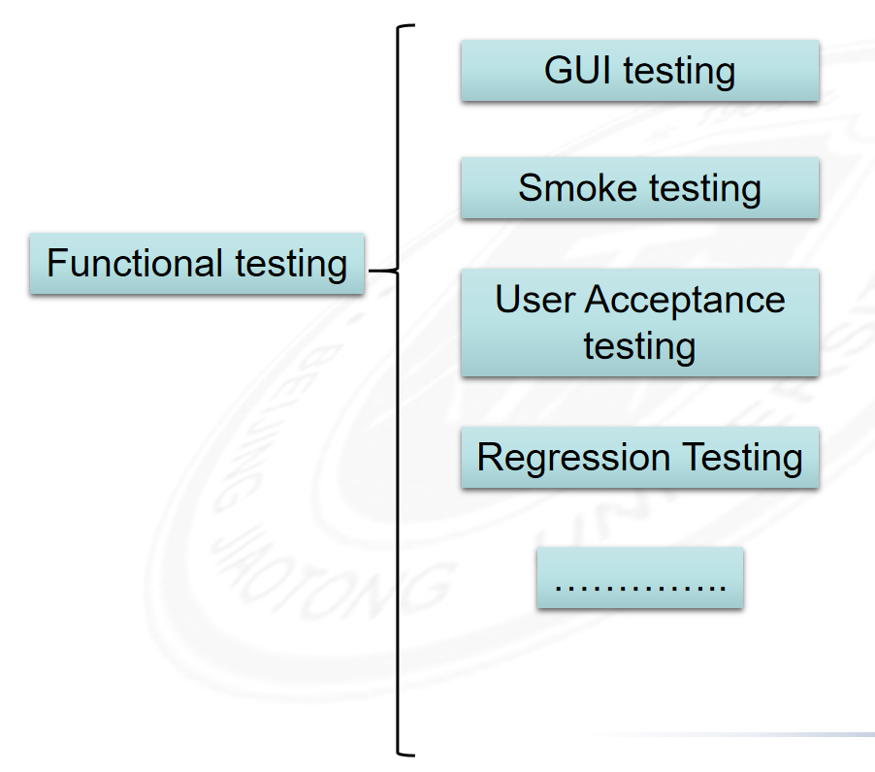

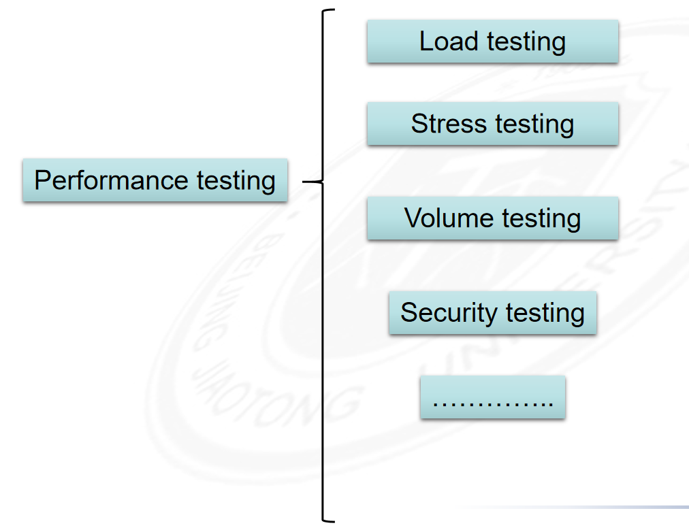

Software Fault : A static defect in the software (i.e., defect)

Software Error : An incorrect internal state that is the manifestation of some fault

Software Failure : External, incorrect behavior with respect to the requirements or other description of the expected behavior

